HTML Self-Closing / Void Element

📘 Definition
# Source: AI Source: Provided by: [Data Path: Persons Table -> ID Column: 1, Name_En Column: Motasem Essam] -> From: [ChatGPT] on [5/6/2026]
A self-closing (void) element is an HTML element that does NOT have a closing tag because it does not contain any content inside it.

🧠 Simple Idea
# Source: AI Source: Provided by: [Data Path: Persons Table -> ID Column: 1, Name_En Column: Motasem Essam] -> From: [ChatGPT] on [5/6/2026]
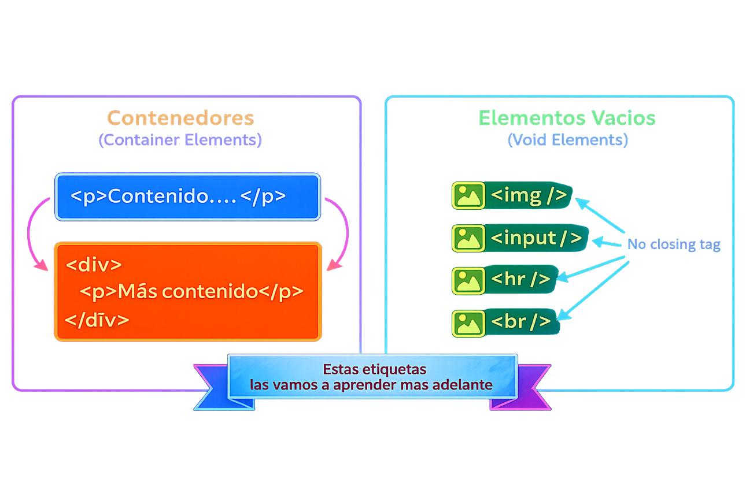
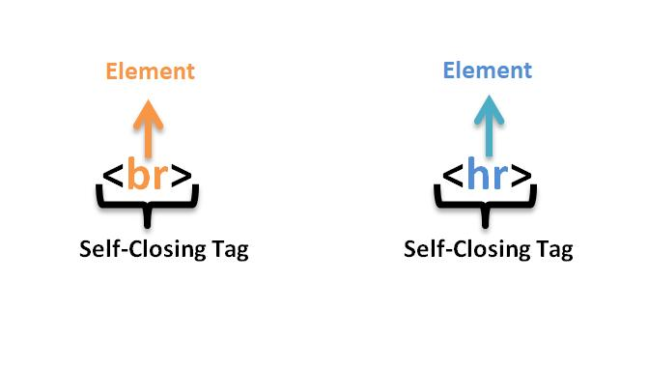
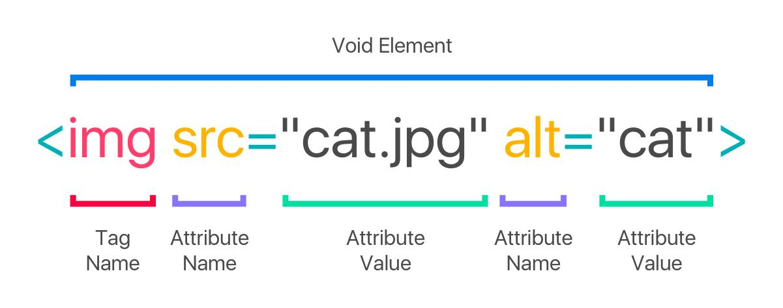
👉 Normal element:
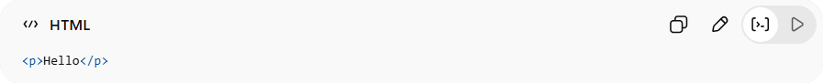
<p>Hello</p>
👉 Void element:
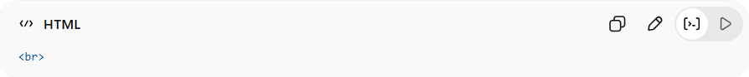
<br>

⚙️ Why they are called “Void”
# Source: AI Source: Provided by: [Data Path: Persons Table -> ID Column: 1, Name_En Column: Motasem Essam] -> From: [ChatGPT] on [5/6/2026]
They are called void elements because:
- They have no inner content
- They are empty by design

📌 Common Void Elements
# Source: AI Source: Provided by: [Data Path: Persons Table -> ID Column: 1, Name_En Column: Motasem Essam] -> From: [ChatGPT] on [5/6/2026]
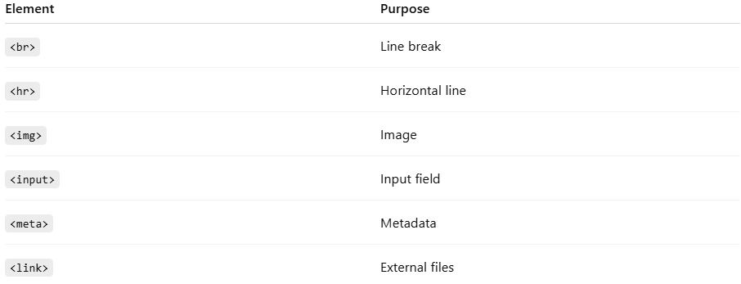
Element | Purpose
<br> | Line break
<hr> | Horizontal line
<img> | Image
<input> | Input field
<meta> | Metadata
<link> | External files

💻 Examples

🧾 1. Line Break
# Source: AI Source: Provided by: [Data Path: Persons Table -> ID Column: 1, Name_En Column: Motasem Essam] -> From: [ChatGPT] on [5/6/2026]
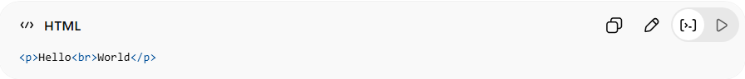
<p>Hello<br>World</p>

🖼️ 2. Image
# Source: AI Source: Provided by: [Data Path: Persons Table -> ID Column: 1, Name_En Column: Motasem Essam] -> From: [ChatGPT] on [5/6/2026]
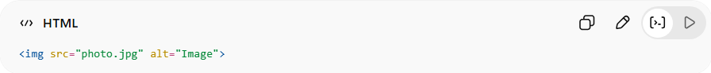
<img src="photo.jpg" alt="Image">

📏 3. Horizontal Line
# Source: AI Source: Provided by: [Data Path: Persons Table -> ID Column: 1, Name_En Column: Motasem Essam] -> From: [ChatGPT] on [5/6/2026]
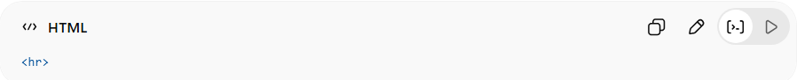
<hr>

🔗 4. Meta Tag
# Source: AI Source: Provided by: [Data Path: Persons Table -> ID Column: 1, Name_En Column: Motasem Essam] -> From: [ChatGPT] on [5/6/2026]
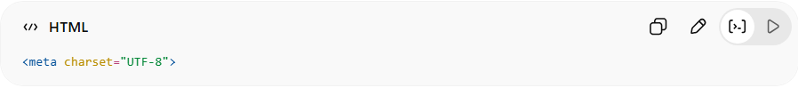
<meta charset="UTF-8">

❌ Wrong Example
# Source: AI Source: Provided by: [Data Path: Persons Table -> ID Column: 1, Name_En Column: Motasem Essam] -> From: [ChatGPT] on [5/6/2026]
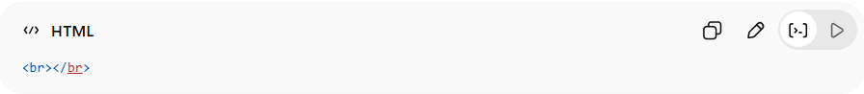
<br></br>
👉 Incorrect because void elements must not have closing tags

🚀 In short:
# Source: AI Source: Provided by: [Data Path: Persons Table -> ID Column: 1, Name_En Column: Motasem Essam] -> From: [ChatGPT] on [5/6/2026]
A self-closing (void) element is an HTML tag that does not need a closing tag because it does not contain any content inside it.

